

User Manual
Employee Module
www.flowhcm.com



Contents
Employee List 3
Add New Employee 4
General Information 5
Additional Information 6
Company Information 9
Employee Documents 10
Salary Information 11
Send Credentials 13
Re-Hire Employee 14
Upload Excel 16
Export Data 17
Employee Profile Request 18
Employee Transfer 20
Employee Role 22
Employee Role 22
Copy Role 23
Role Templates 24
Employee Info Request 25
Employee Resignation 26
View Report 27
Suggestions 28
Employee Approvals 29
Amend Employee Department 30
Apply Same Department 31
Employee Setting 32
Employee Info Approval Setting 33
Employee Field Mandatory Settings 34
Suggestion Category 35
General Employee Setting 36

Employee List
- Click on Employee on the top navigation bar
- Here you can see the Employee list form
- The form consists of multiple functions/buttons

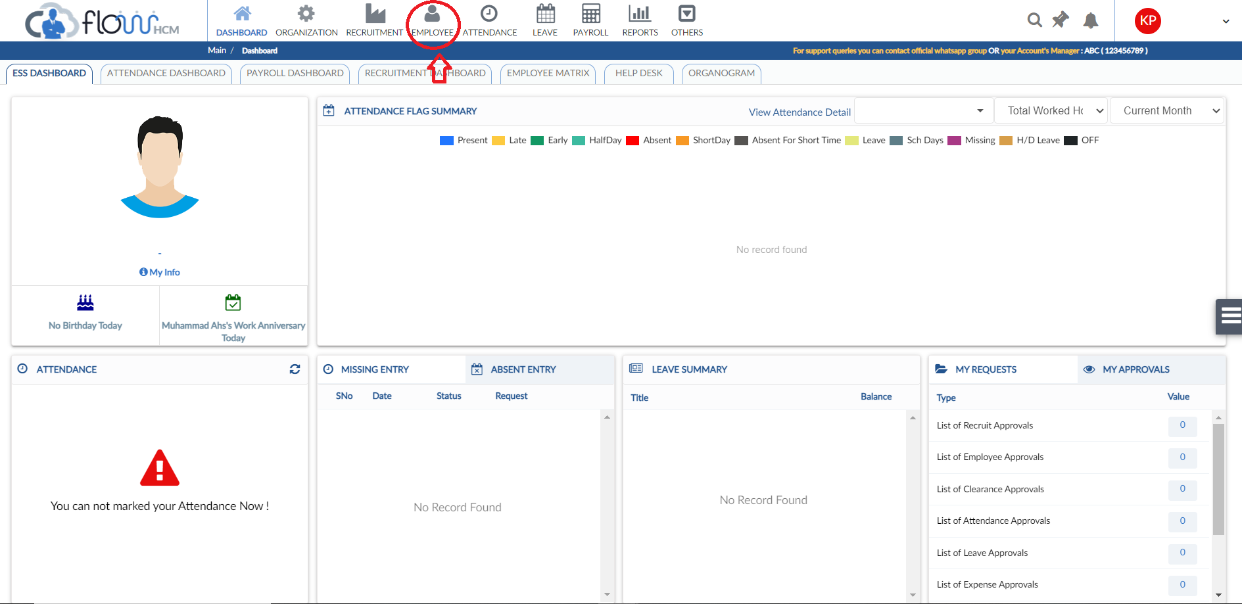
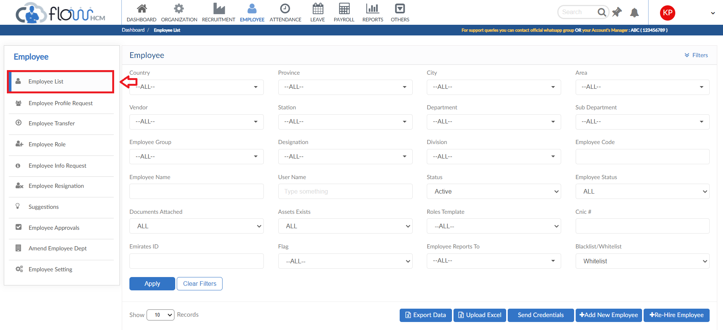

Add New Employee
- To add New Employee, click on Add New Employee button
- The forms is divided into group information to be filled
- After filling all the details click on submit button
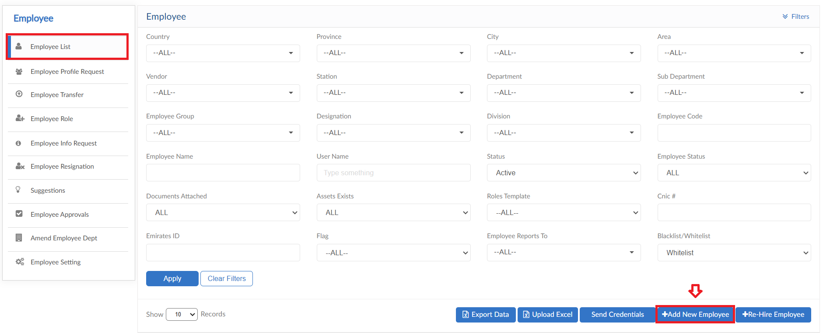

General Information
- The form contains the general information of employee
- That will be used throughout the system
- Fill the details and then click on Next button
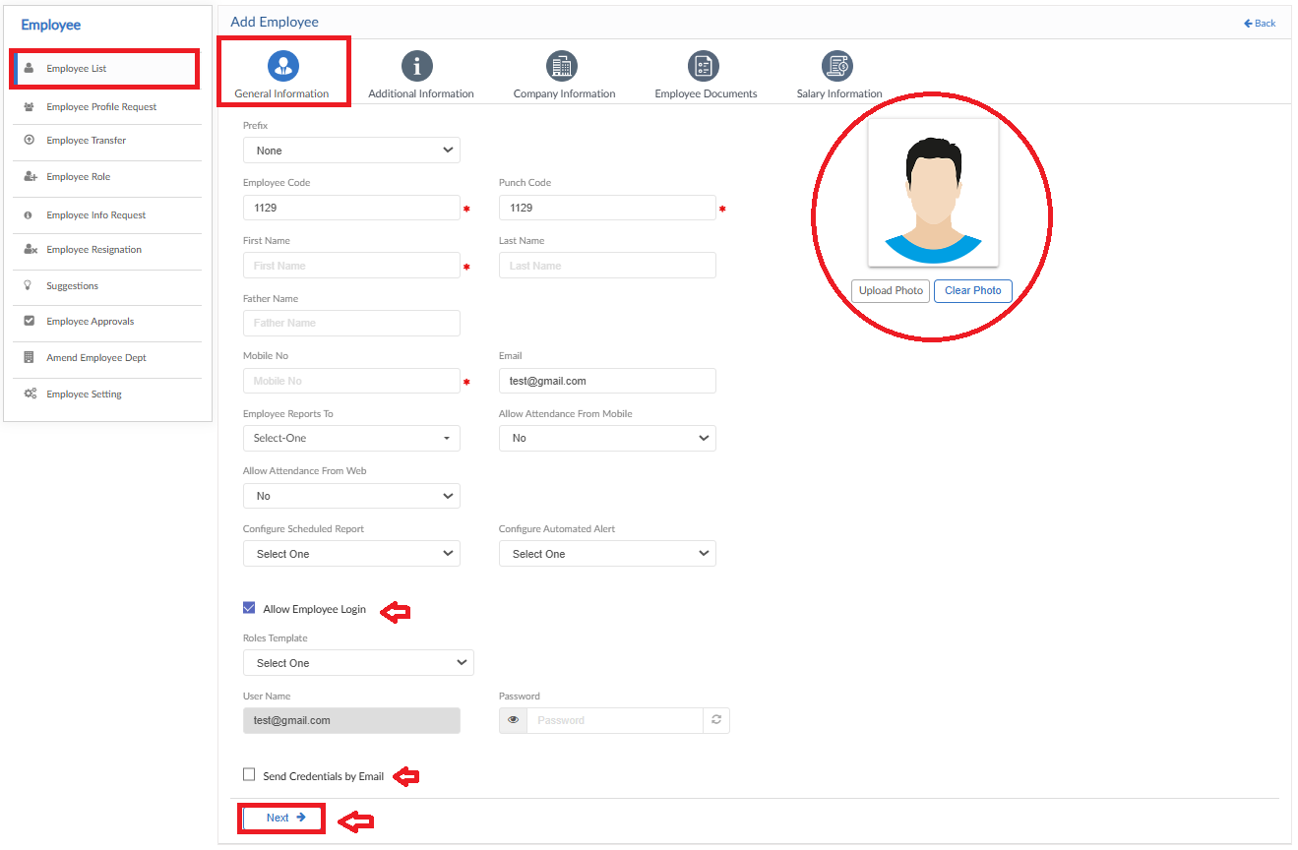

Additional Information
- The form will be filled with additional information of employee
- Details such as Contact, Bank, Emergency information etc. that is required by the organizational documentation
- Fill the details and then click on Next button
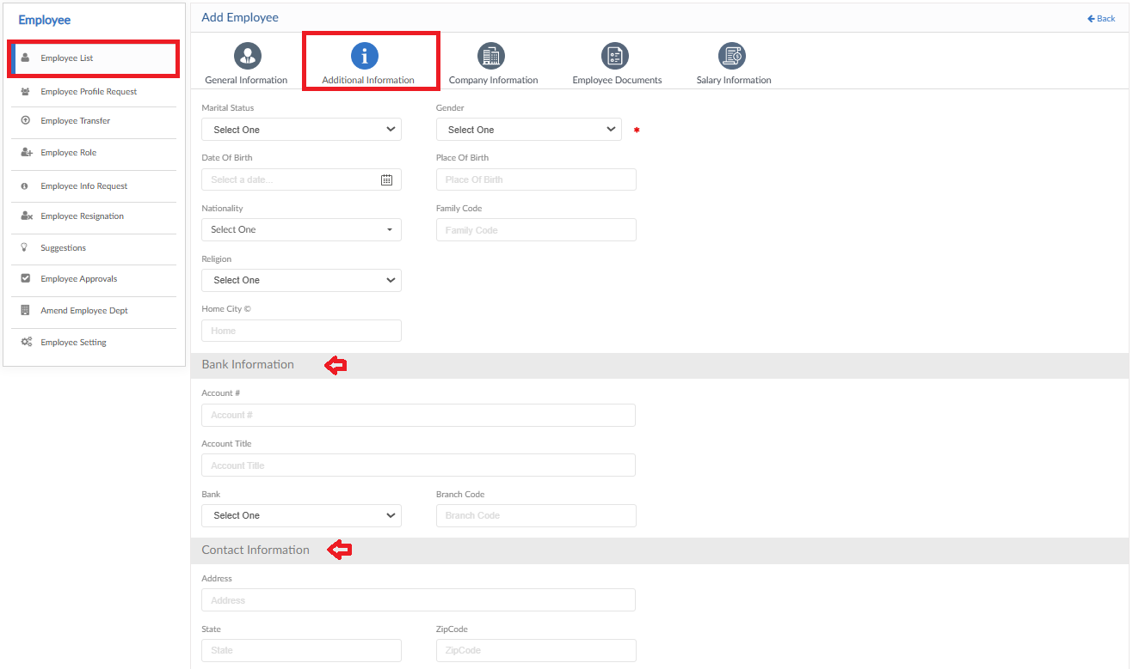
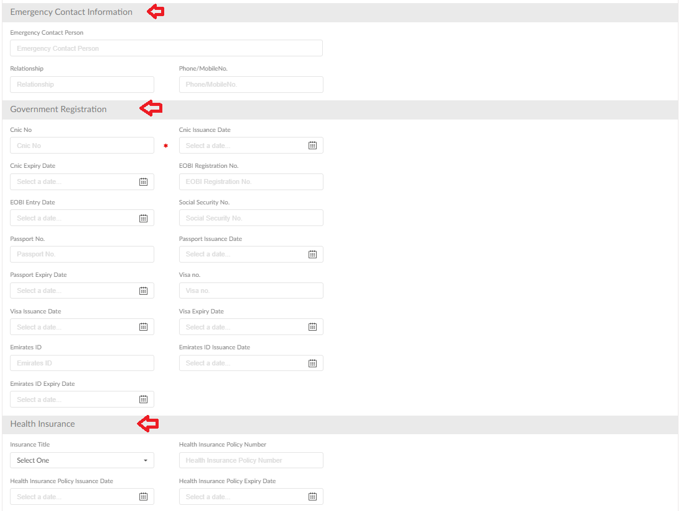
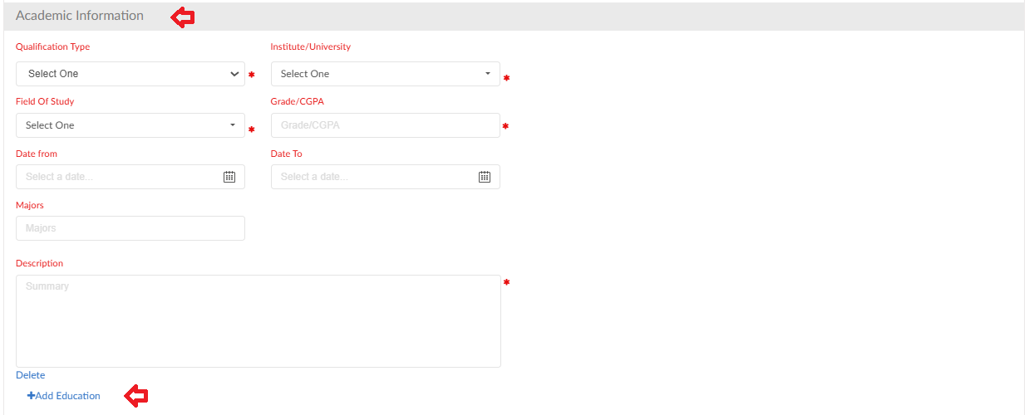
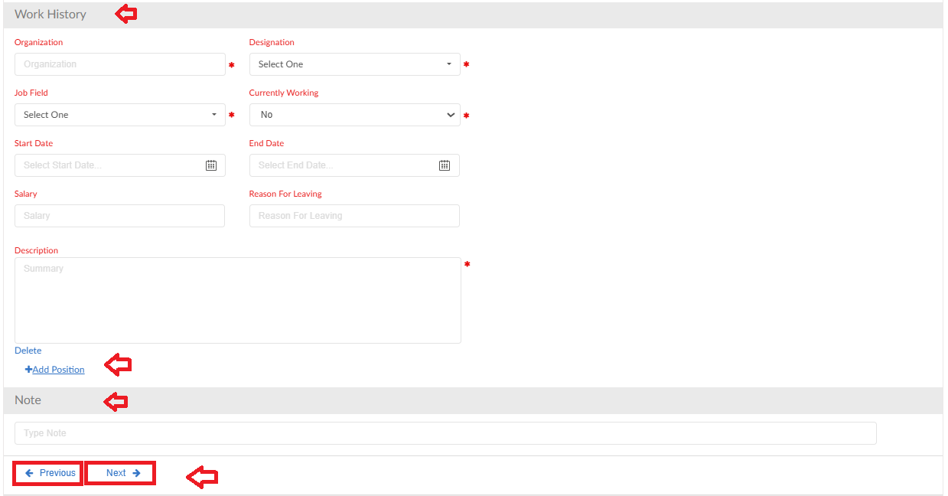

Company Information
- The form will be filled with the Company mapping of employee
- Employee stationed as & where and appointment information
- Fill the details and then click on Next button

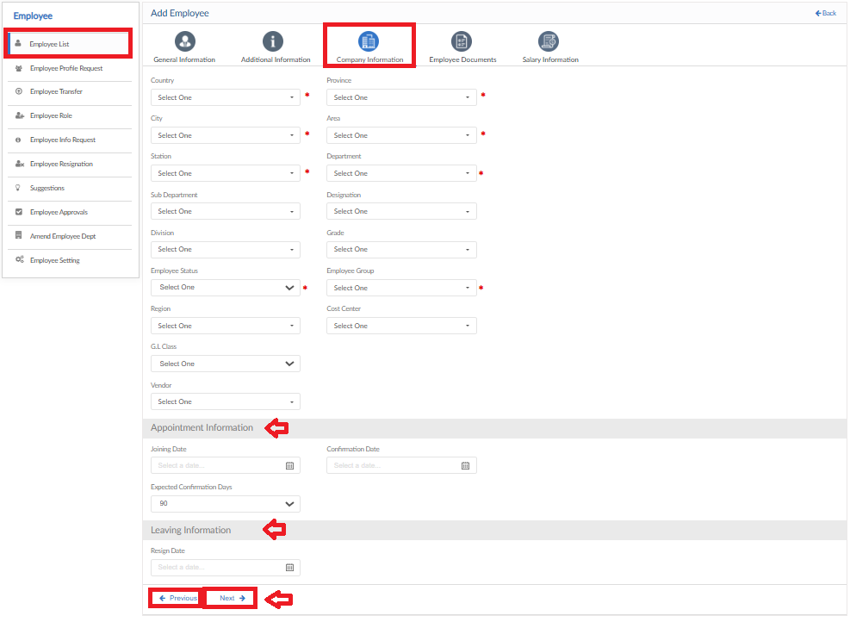

Employee Documents
- In this form employee documents can be added
- To neglect the paper work, upload all documents
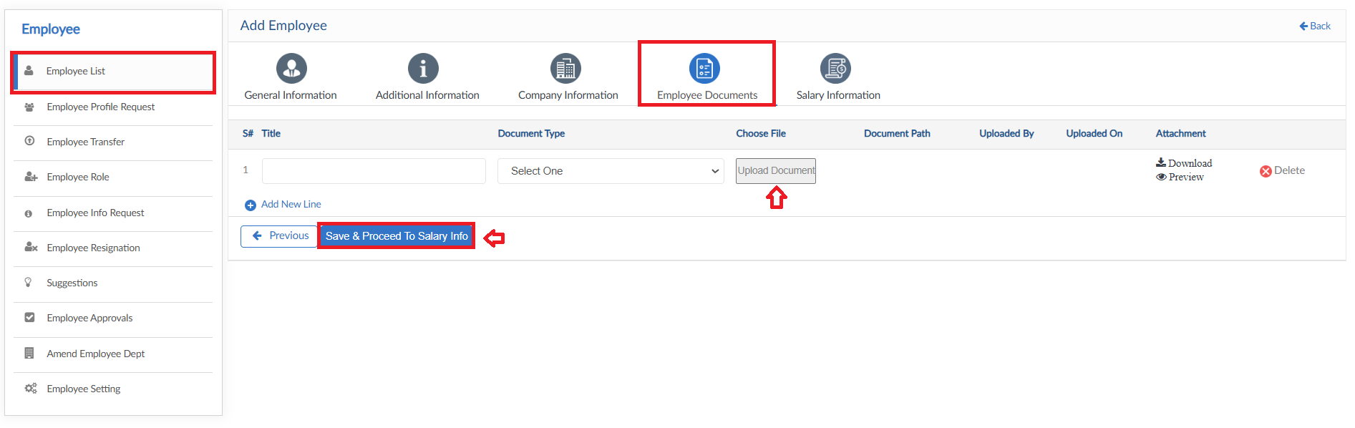

Salary Information
- This form will be filled with Salary information of employee
- All payable setups will be defined (Overtime – Allowance – Deduction – Salary breakup)
- Click on Save button after details are entered
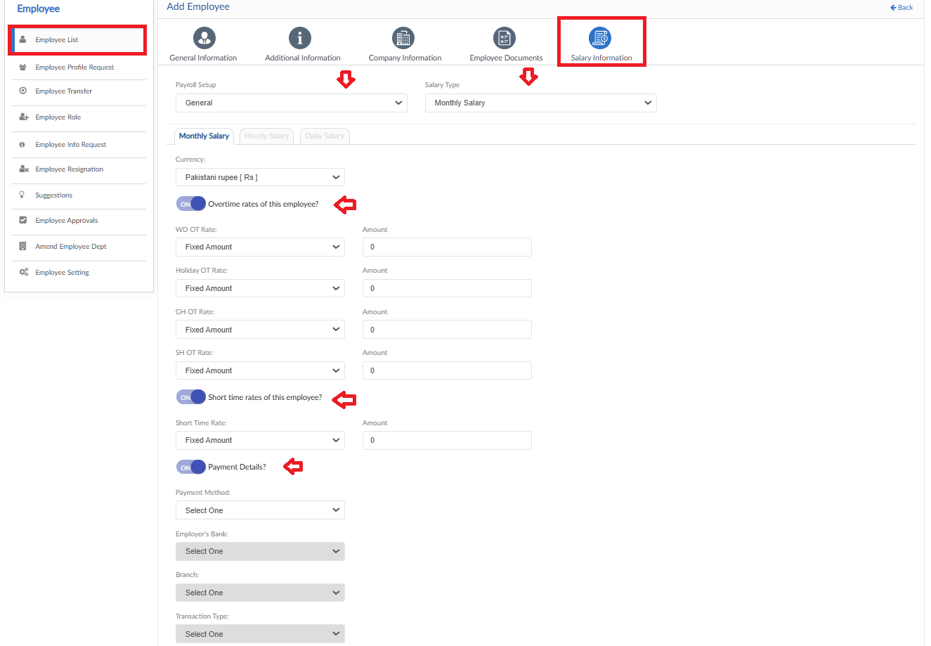

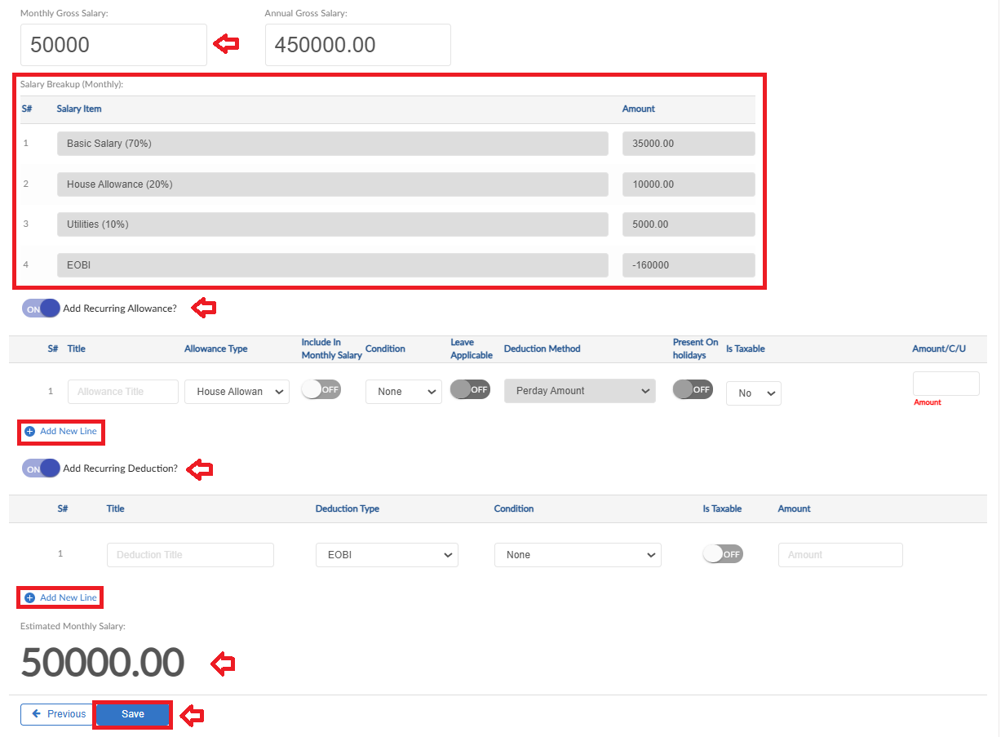

Send Credentials
- If required, to send employee application credentials in one go
- Click on Send Credentials button, pop up will be visible
- Select the criteria of employee’s
- Then click on Save button to send the credentials to selected employees
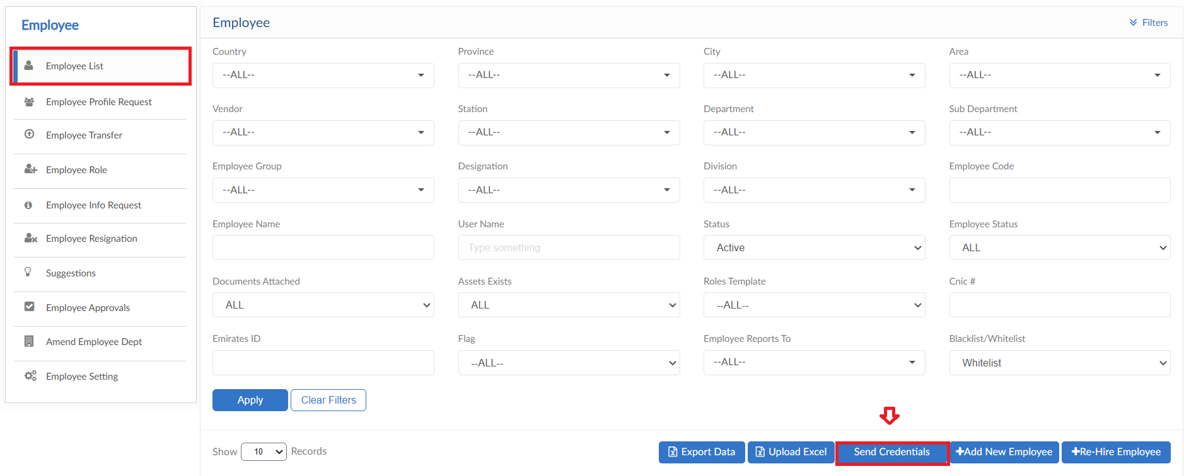
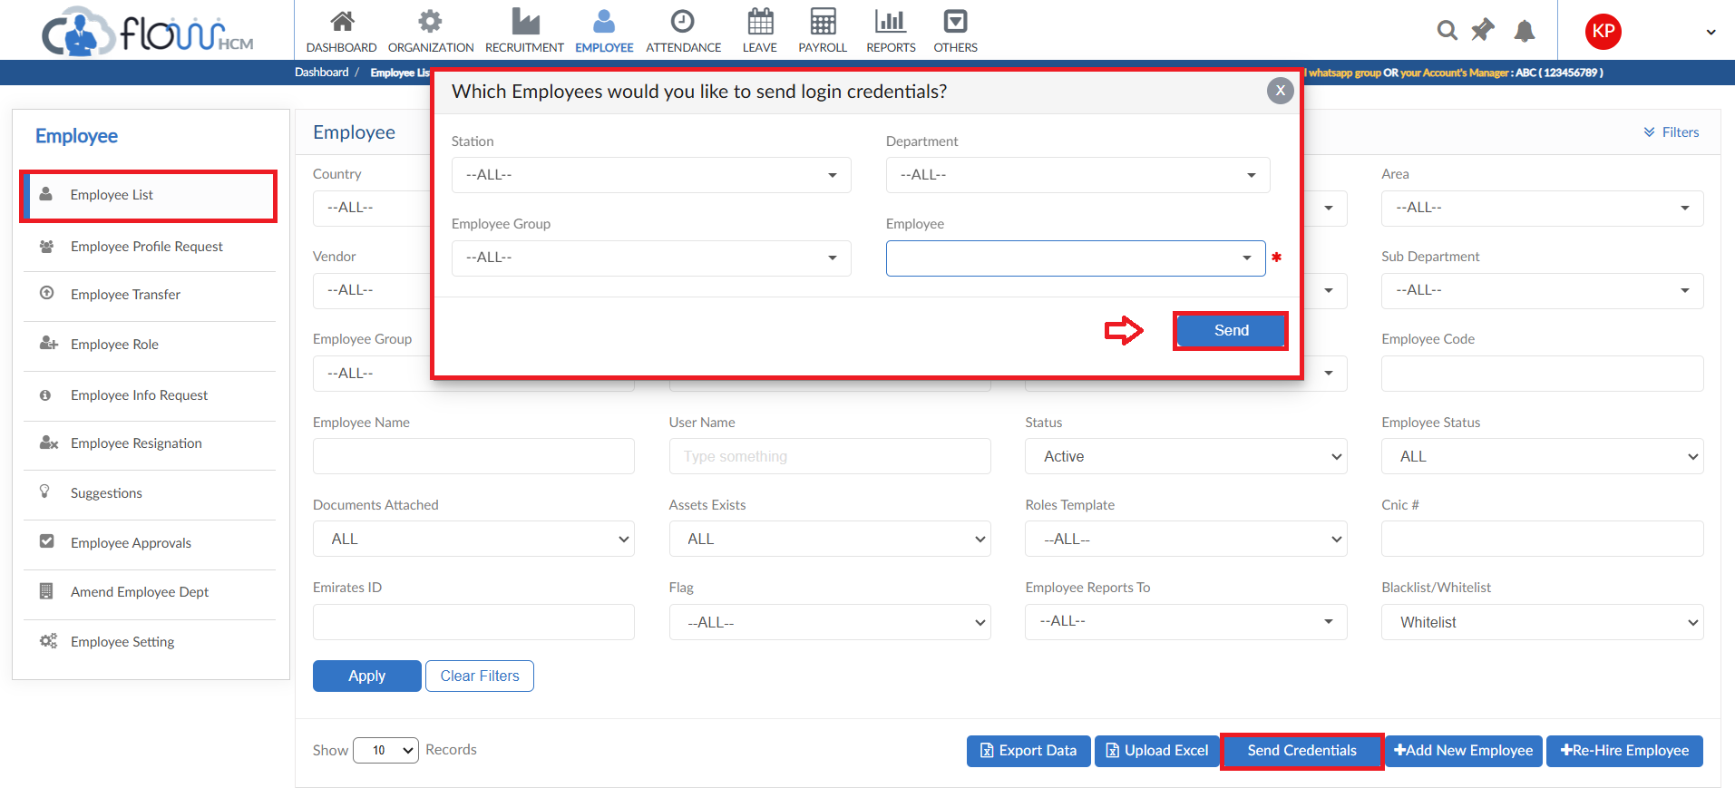

Re-Hire Employee
- System has a provision to re-hire any employee
- Click on Re-Hire Employee button, pop up will be visible
- Search the employee by CNIC No. and click on Search button
- Employee will be visible in Inactive Employee dropdown
- Select the employee and click on Rehire button the form will be visible with data
- Change the required data and then click on Rehire button
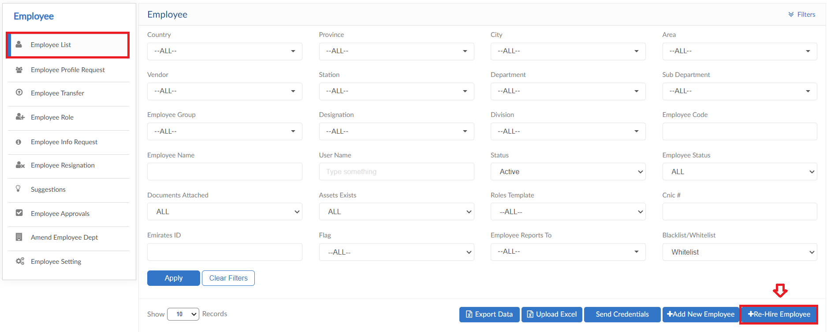
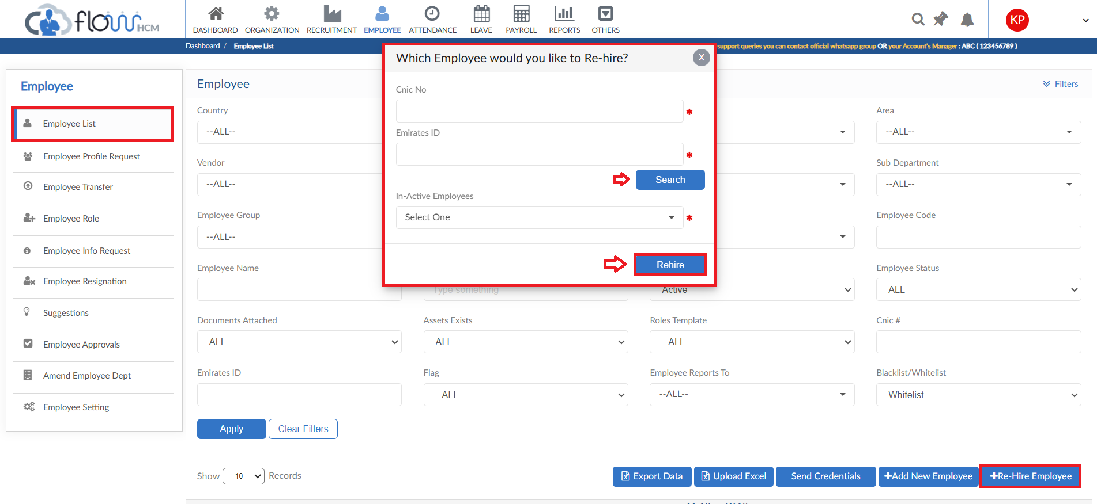
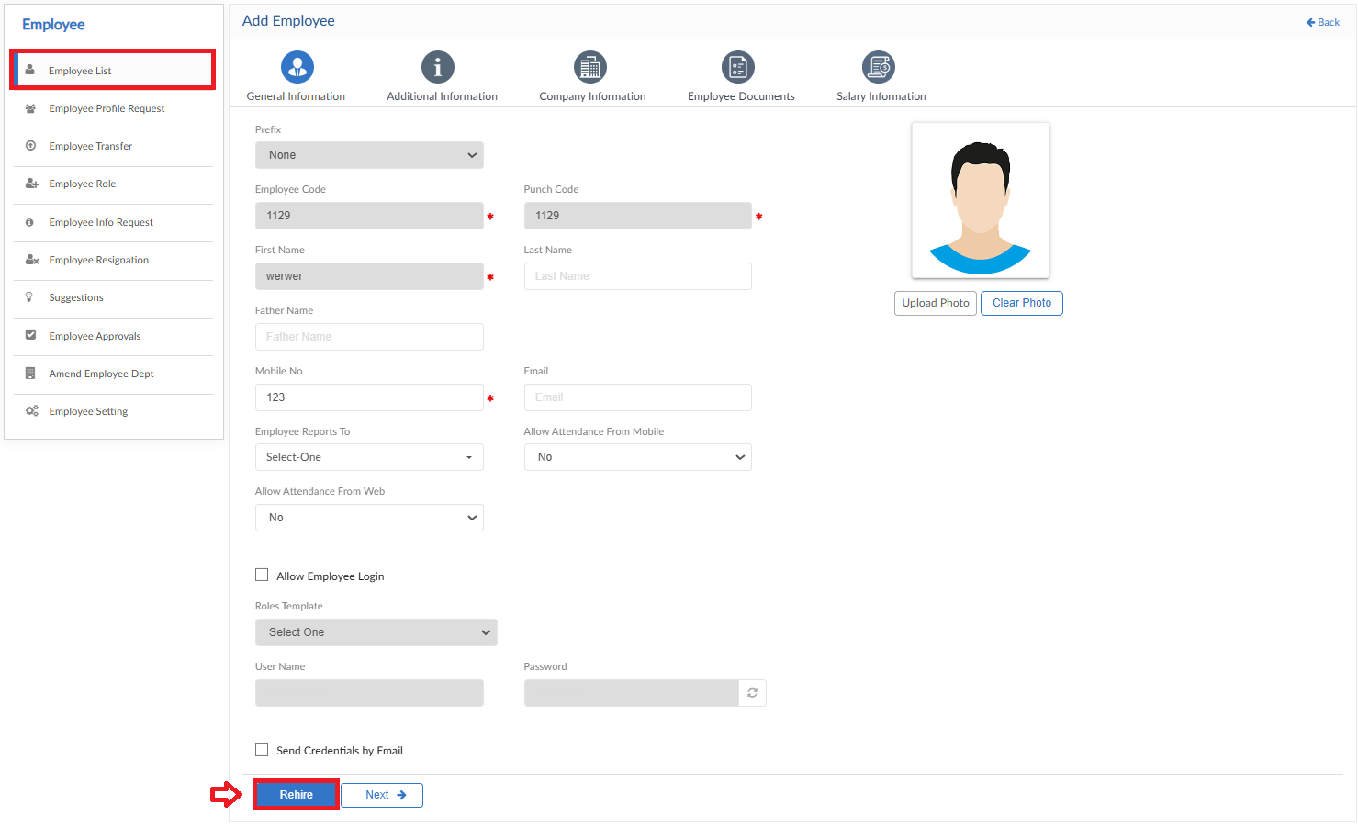

Upload Excel
- If required, upload all employee data in one go user can use upload excel
- Click on Upload Excel button, pop up will be visible
- Then click on Download Sample Template and enter required data
- Click on choose file and then click on Save button to upload all employee data
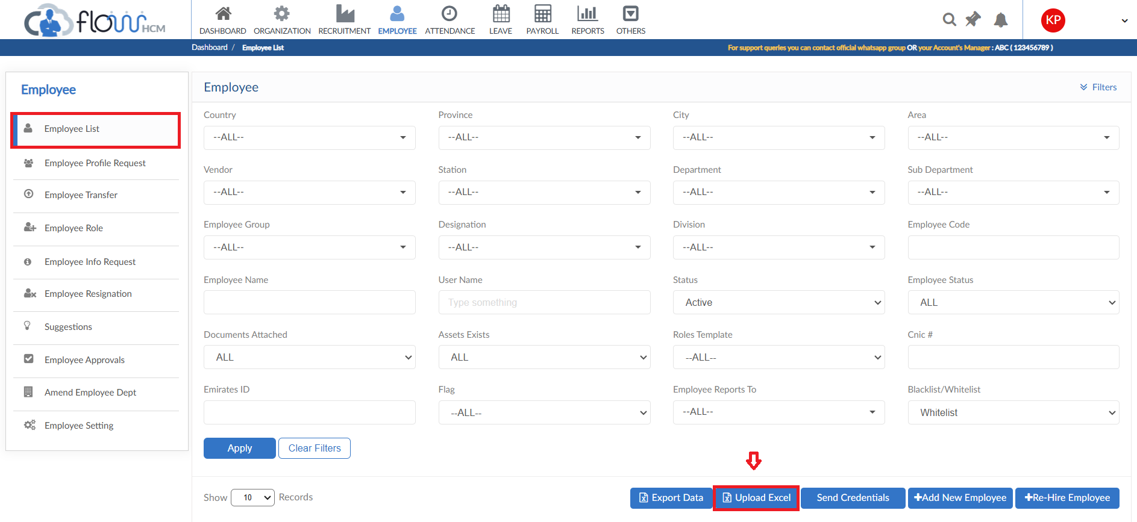
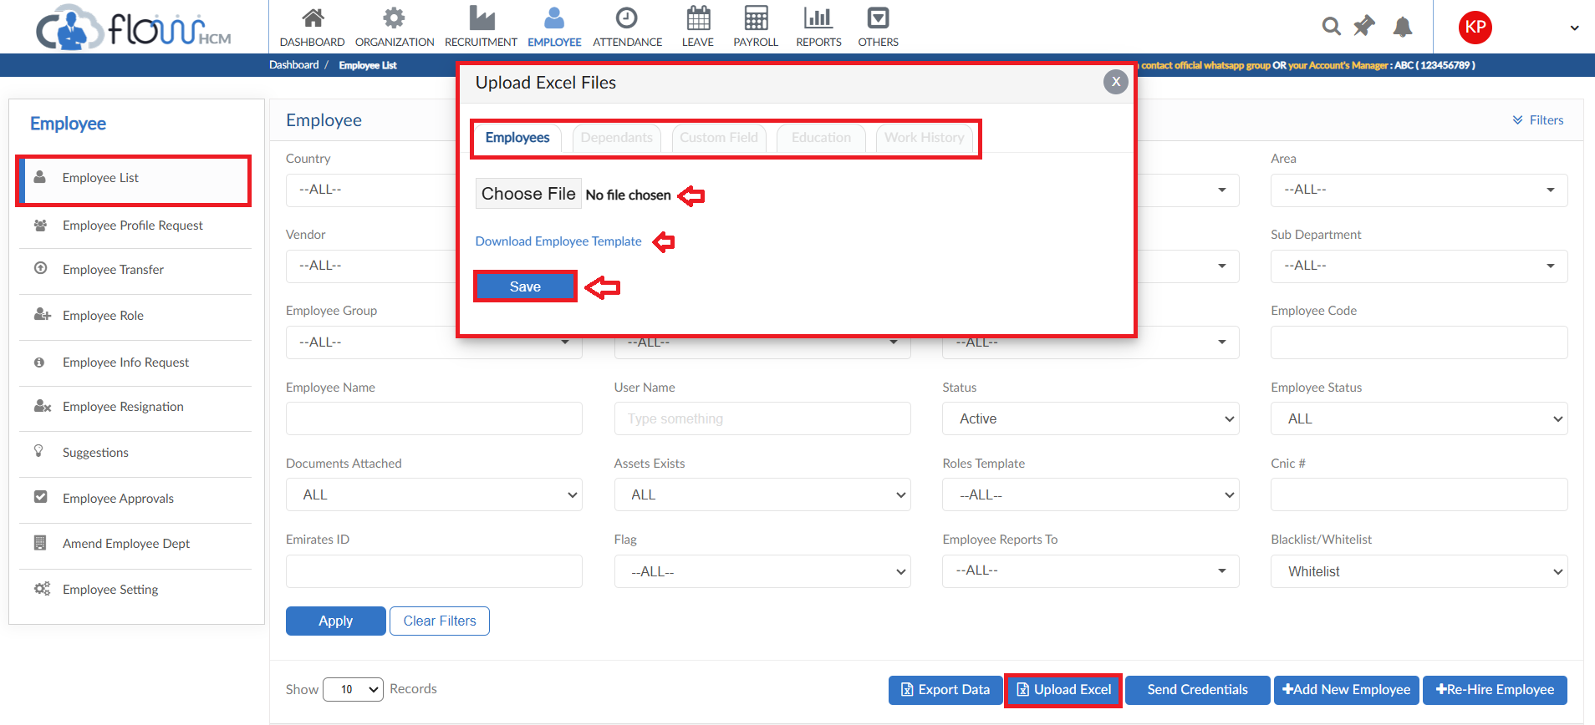

Export Data
- To export all data of employee from system into one file
- Click on Export Data button, pop up will be visible
- Select the required data and click on Export button
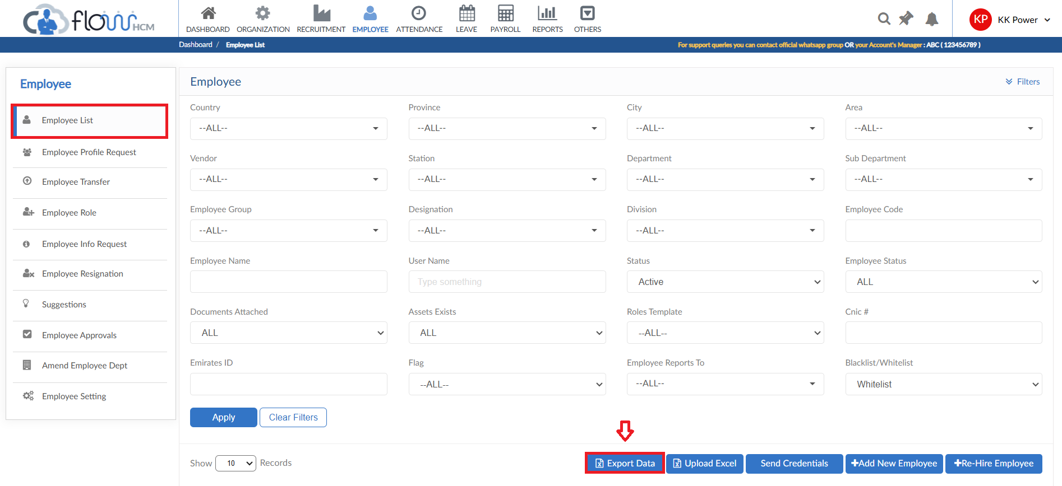
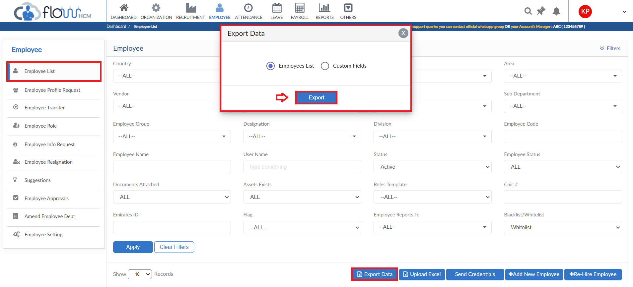

Employee Profile Request

- To add an Employee Profile Request, click on Add New Employee
- Employee form will be visible, fill all the data then click on Save button
- The requisition will be submitted
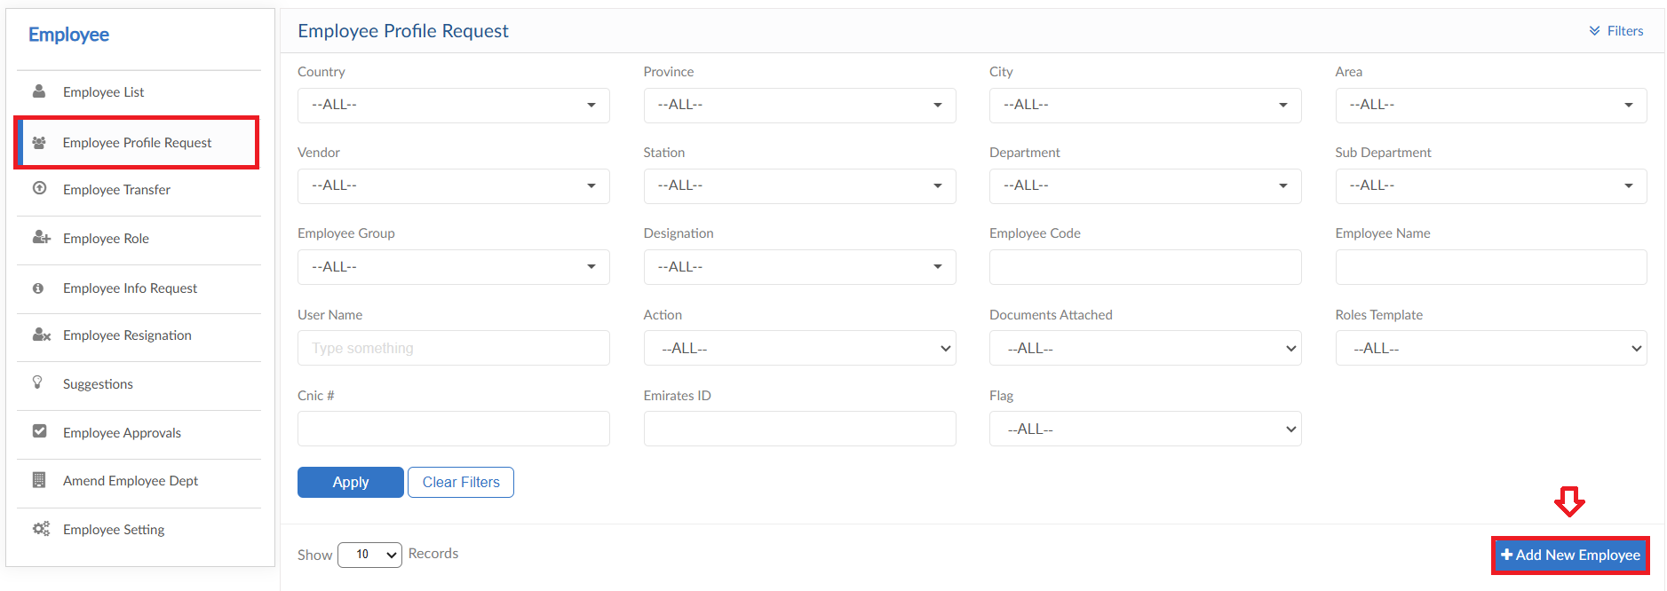
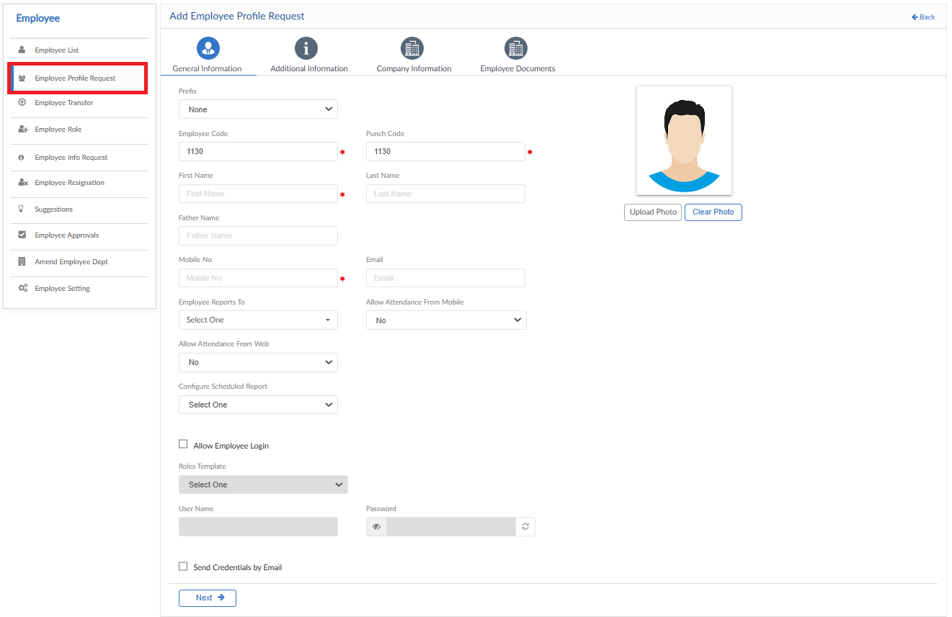

Employee Transfer

- To add Employee Transfer Request, click on Apply for Employee Transfer
- Select employee, Type and date for transfer
- System will auto fill the fields with current data of employee
- Enter the required changes in data, a table is also visible to track data
- After details are entered add a description against request
- Then click on submit to raise a requisition
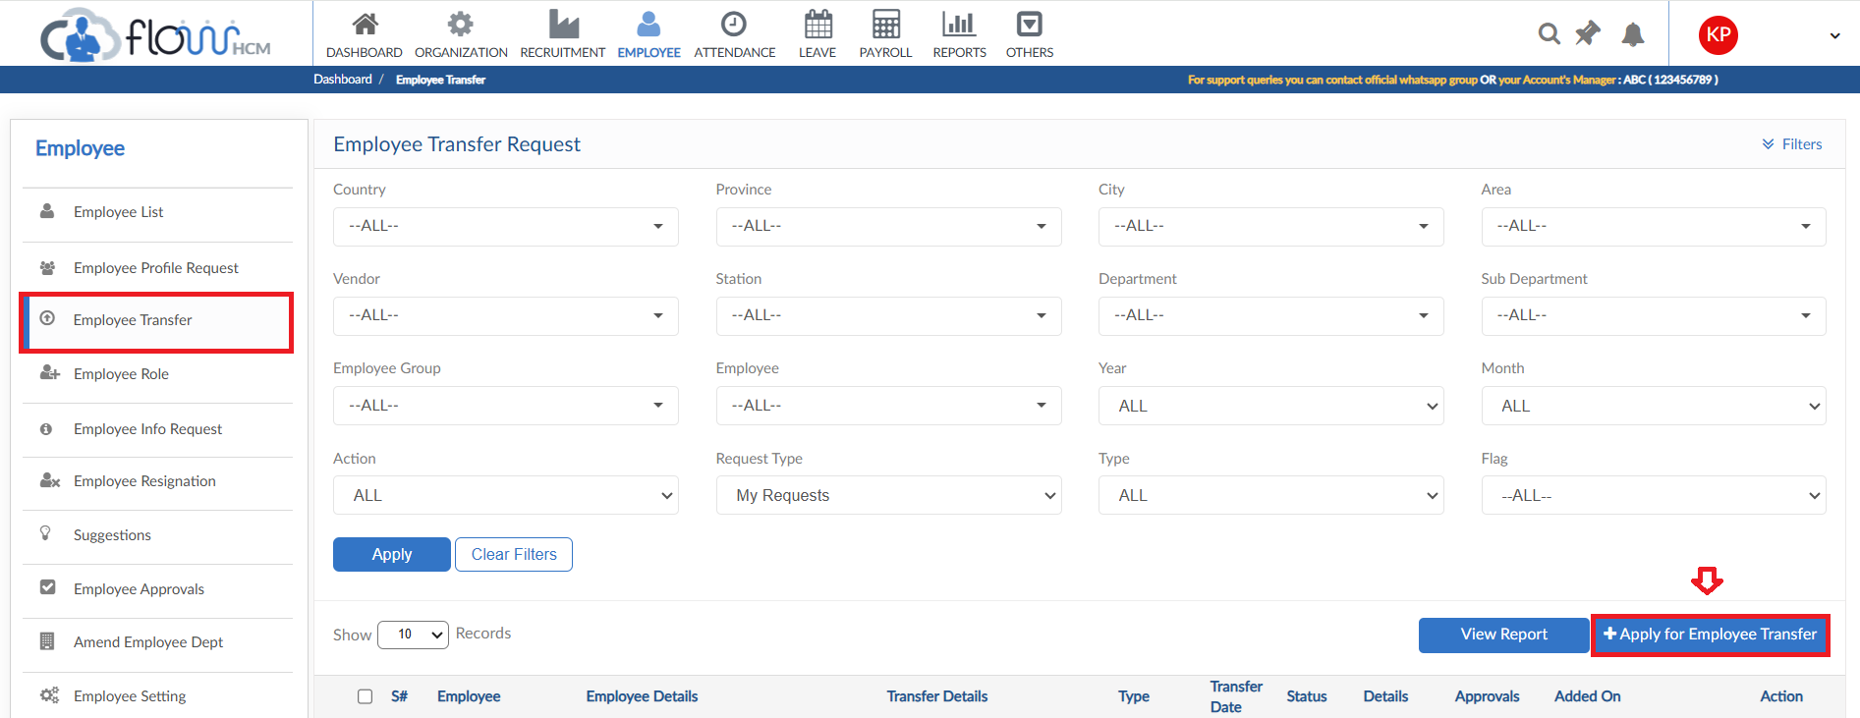
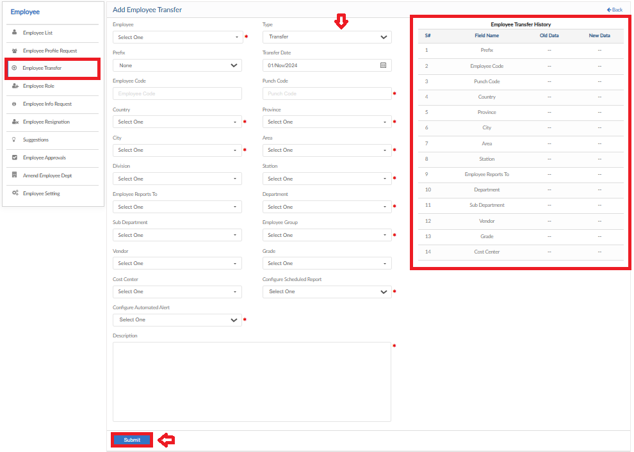

Employee Role

Employee Role form consists of multiple template forms

Employee Role
- Employee Role form allows to change user rights within the application
- Select the employee from dropdown
- Either click on Apply Role template and map a certain template from list or can change rights manually module wise
- After changes click on Save button
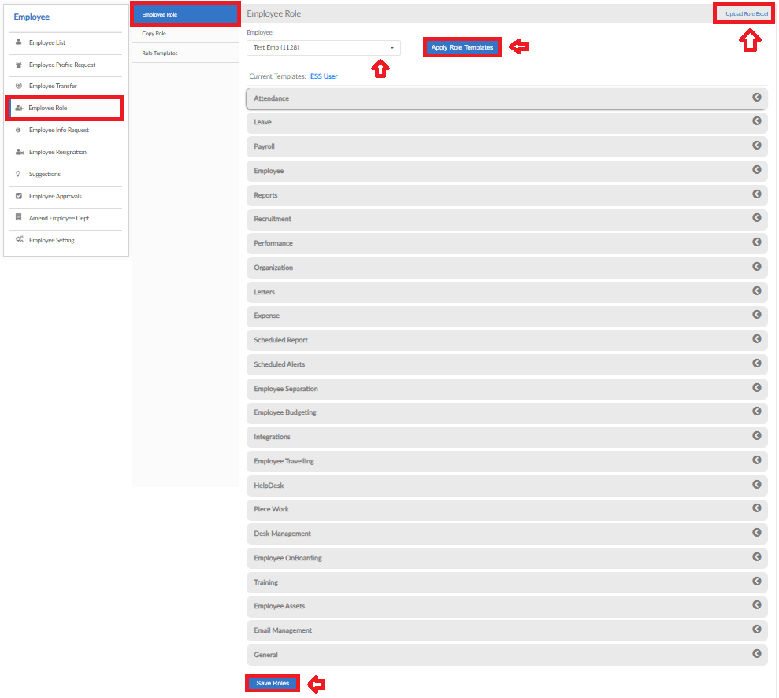

Copy Role
- Copy Role form allows you to copy template from a user to another
- Select the required employees from dropdowns
- Then click on Save button
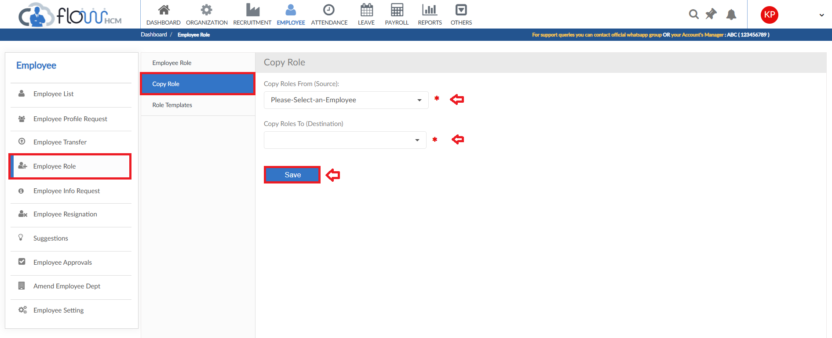

Role Templates
- Role Template form allows to either create a new or change any current template
- Click on Create New template and adjust rights
- Else select template from dropdown and make changes to that template
- Then click on Save Template button
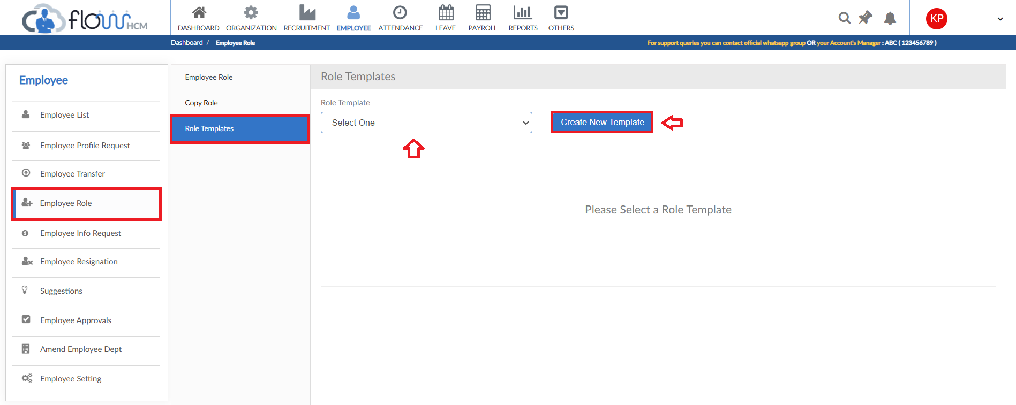

Employee Info Request

- To add an Info Request, click on Employee Info Request form
- Click on Apply for Employee Info button
- Select Employee from dropdown, system will autofill fields
- User can only change the data in enabled fields
- After the changes click on Submit request to raise a requisition
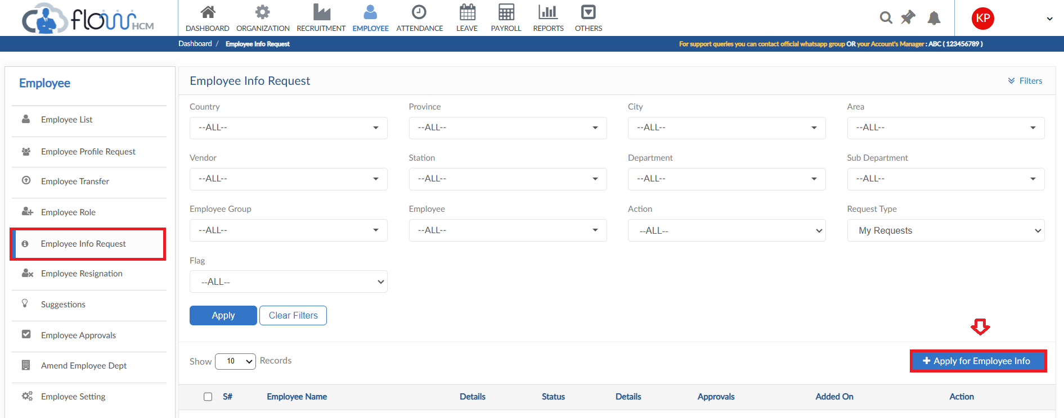
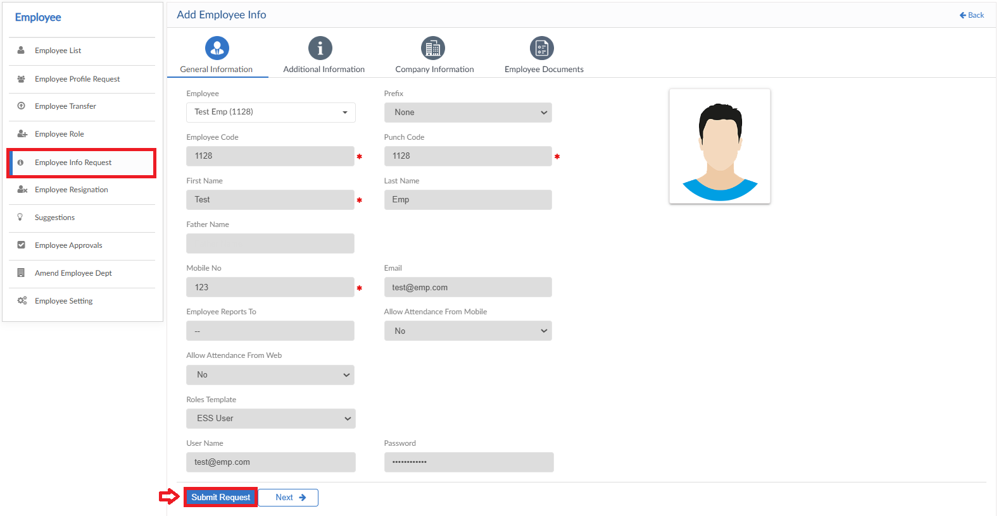

Employee Resignation
- To add a Resignation Request, click on Employee Resignation form
- Click on Add New Request button
- Select Employee and Resignation date
- Define resignation reason and enter Last working date
- File can be attached if required
- Enter a reason for request then click on Submit button to raise a requisition
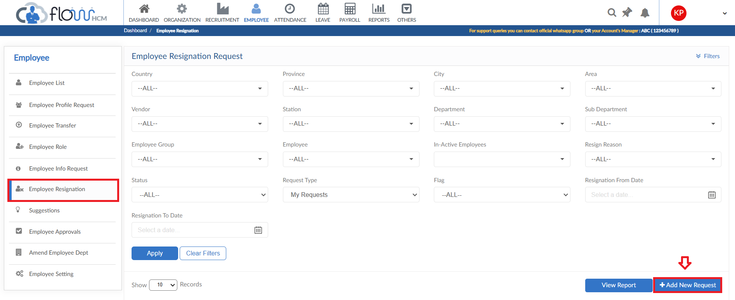
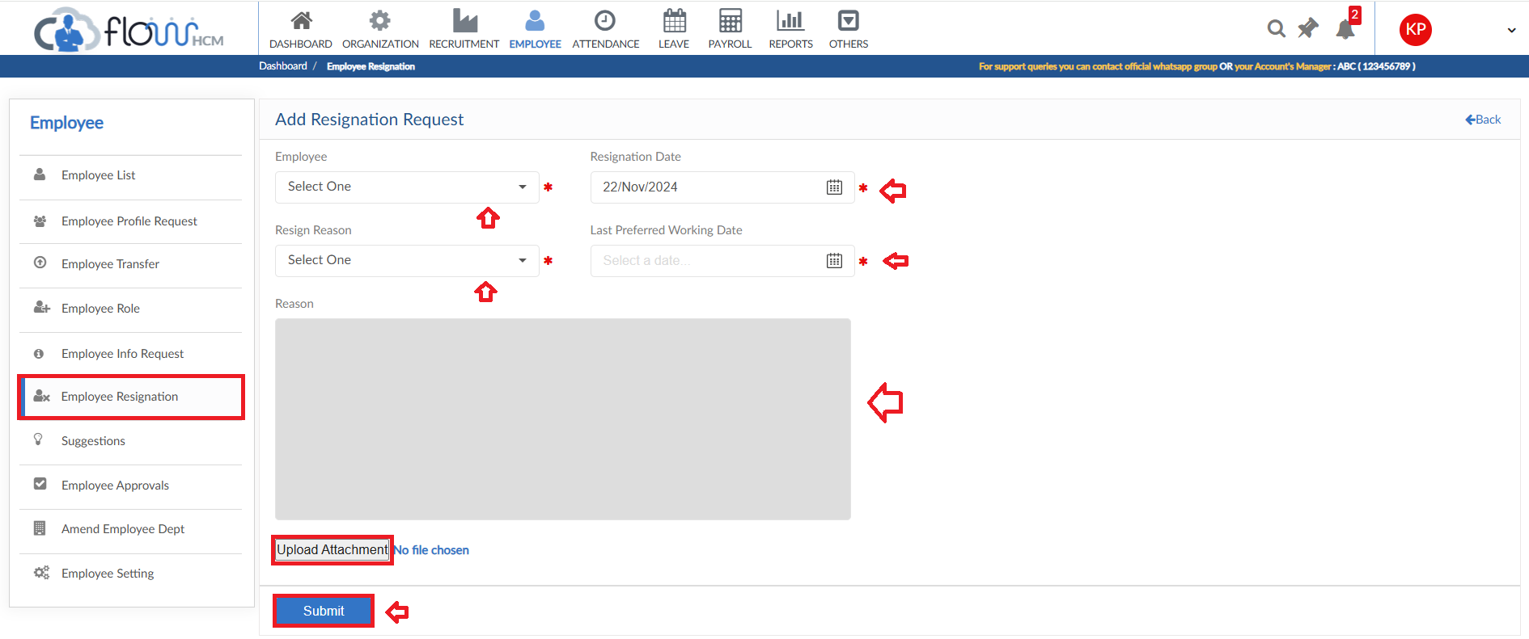

View Report
- To view the data of grid in Employee Resignation form click on view report
- Resignation Request Report will pop up on screen
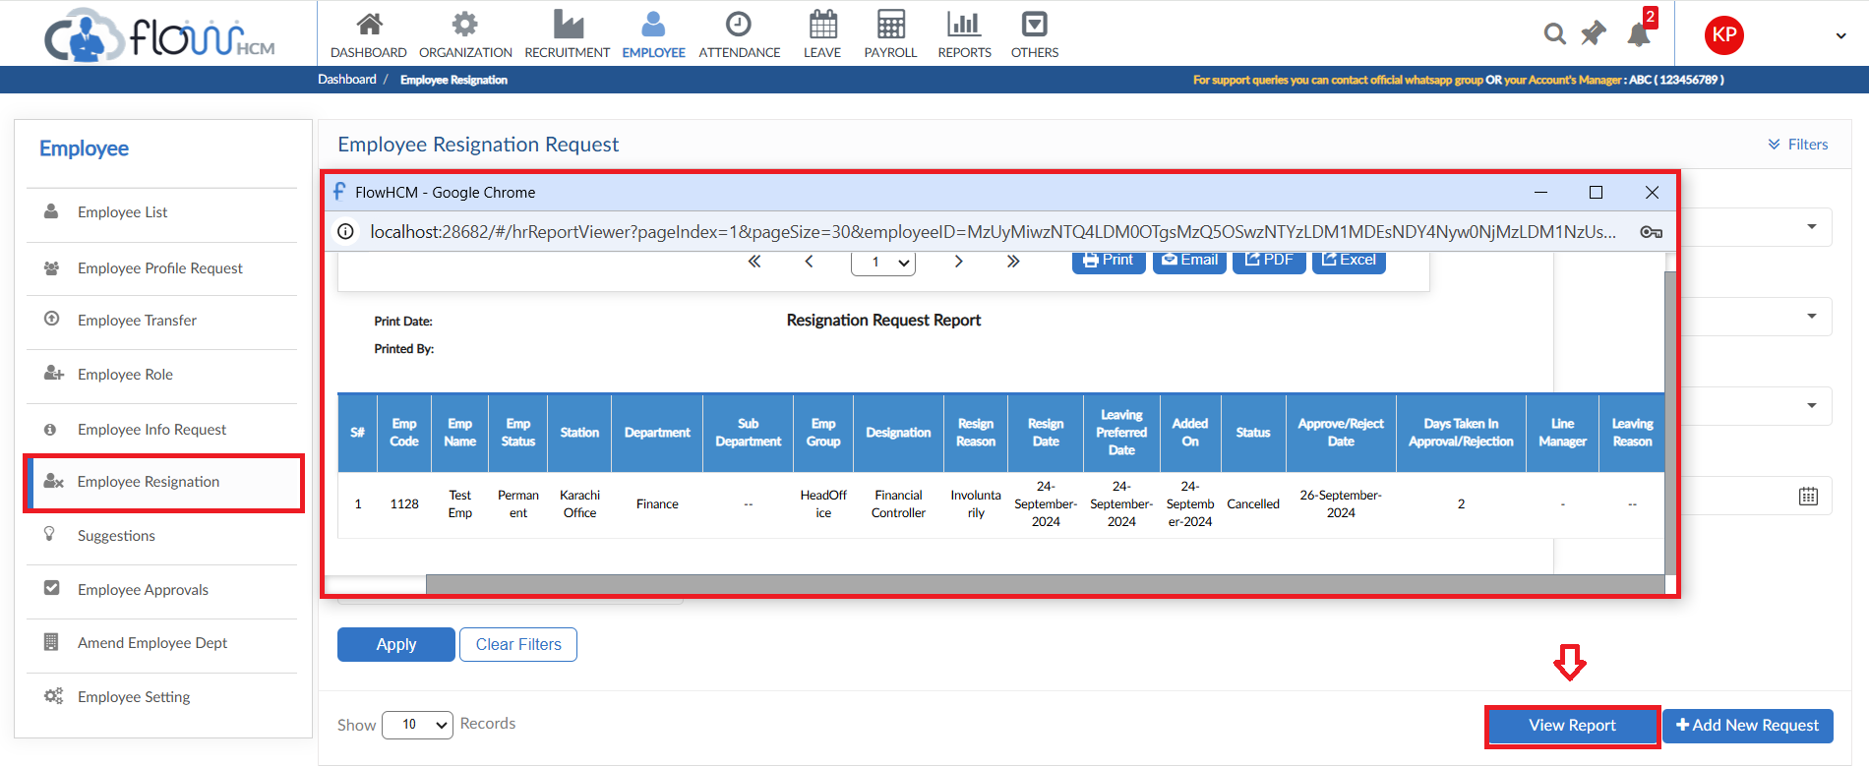

Suggestions

- To add a Suggestion Request, click on Add New Suggestion
- Enter Suggestion Title and Select category from dropdown
- Select either the suggestion should be sent anonymously or not
- Define the suggestion in box
- Then click on submit to raise a requisition
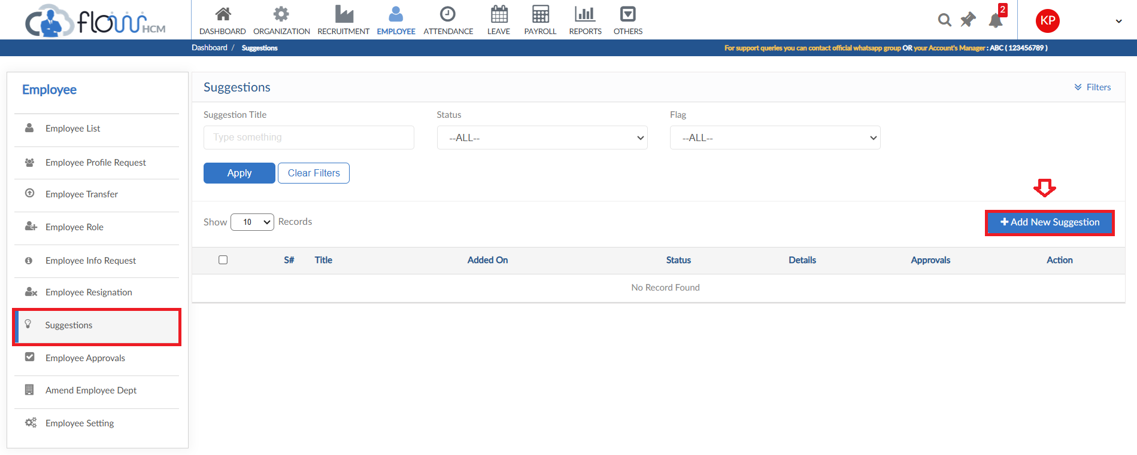
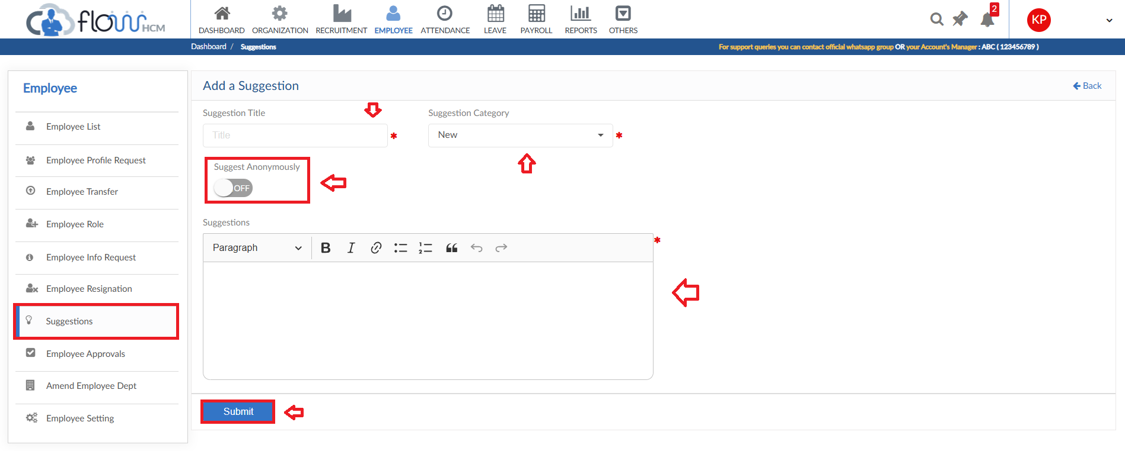

Employee Approvals

- All the requests of Employee Module will fall in Employee Approval form
- User can select criteria for specific requests and click Apply button
- System will fill the grid with required data
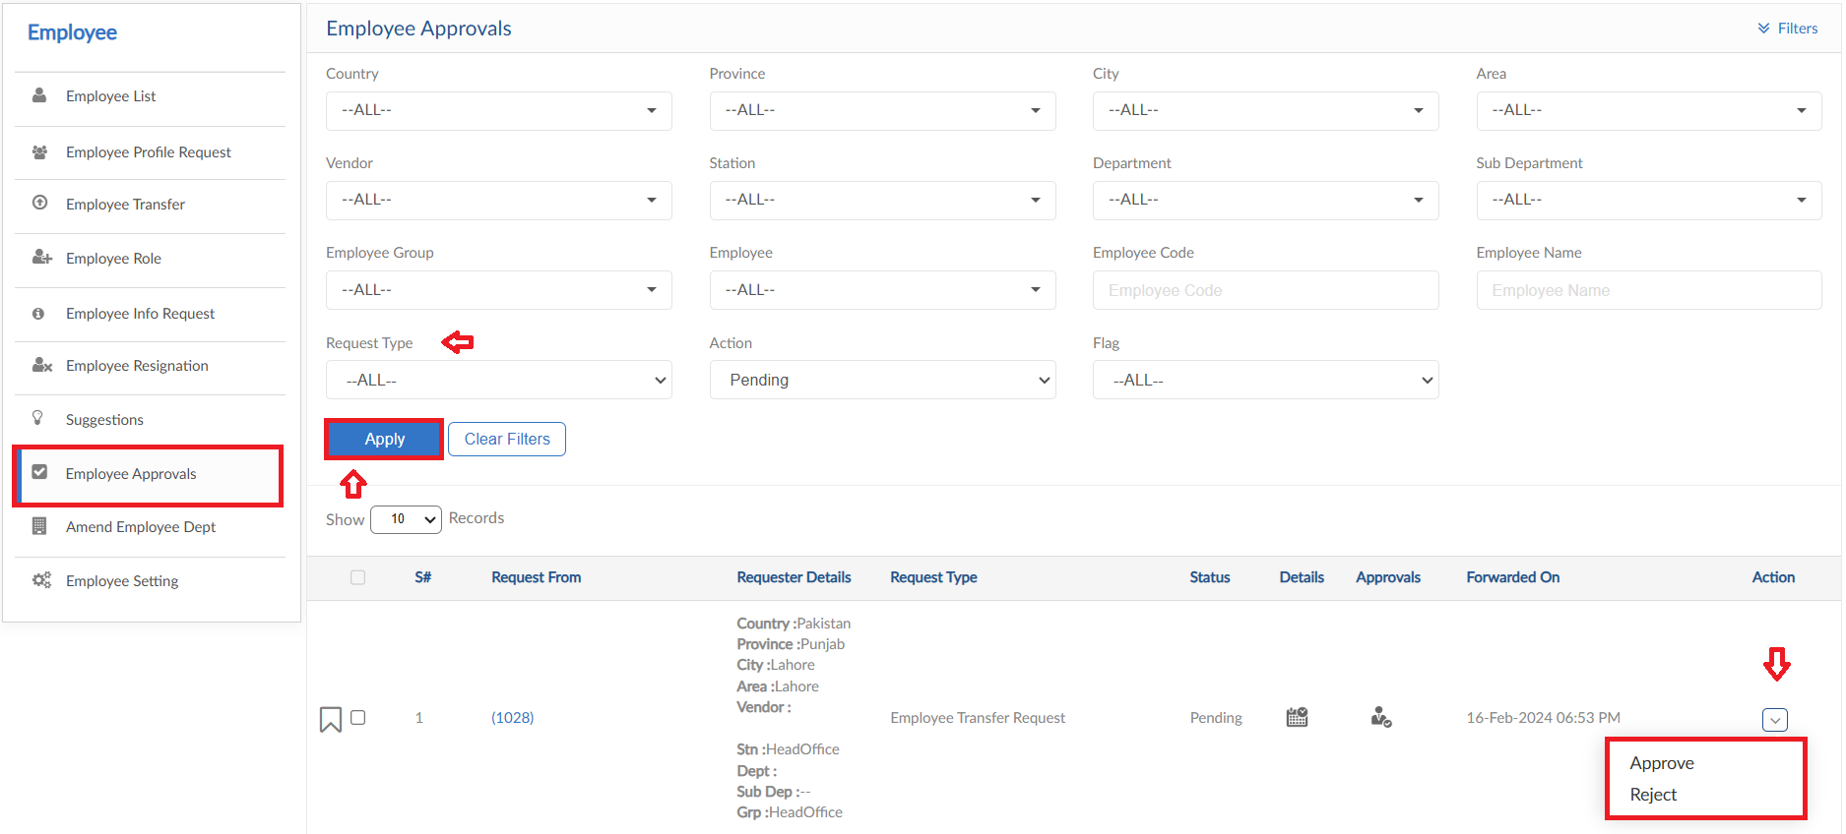

Amend Employee Department

- To make amendments in Employee Departments, click on Amend Employee Department form
- Select the criteria & Date range (From – To) and click on apply button
- System will show the required data on grid
- Check mark the rows that needs changes, select the department from dropdown then click Save button
- The selected rows will be saved with entered data
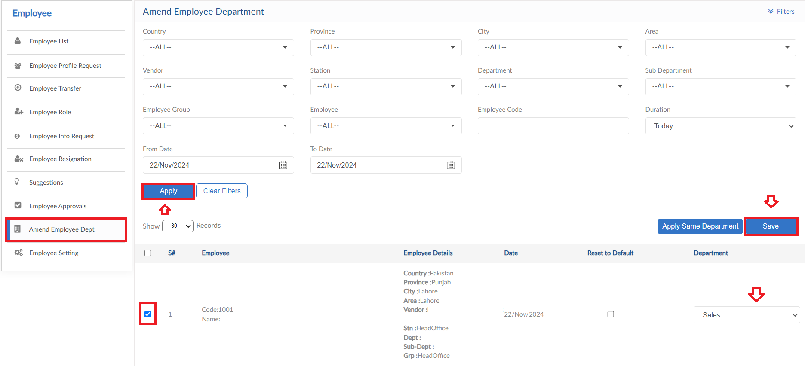

Apply Same Department
- If required, to map same department to multiple employee select the required rows
- Then click on Apply Same Department button, a pop up will be visible
- Select the department to be mapped then click on save button
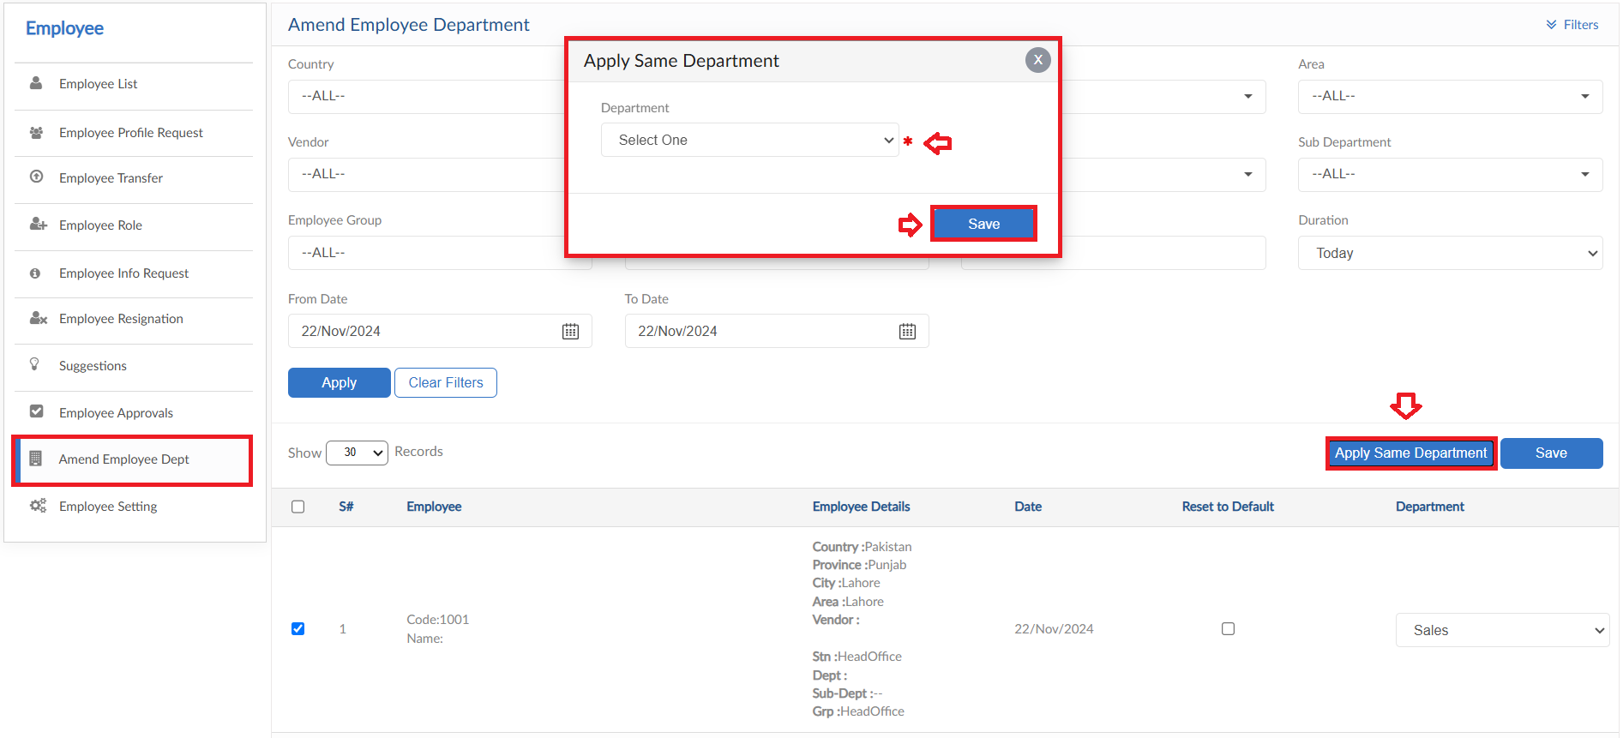

Employee Setting

- Employee Setting form consists of multiple setup forms
- Click on Employee Setting form
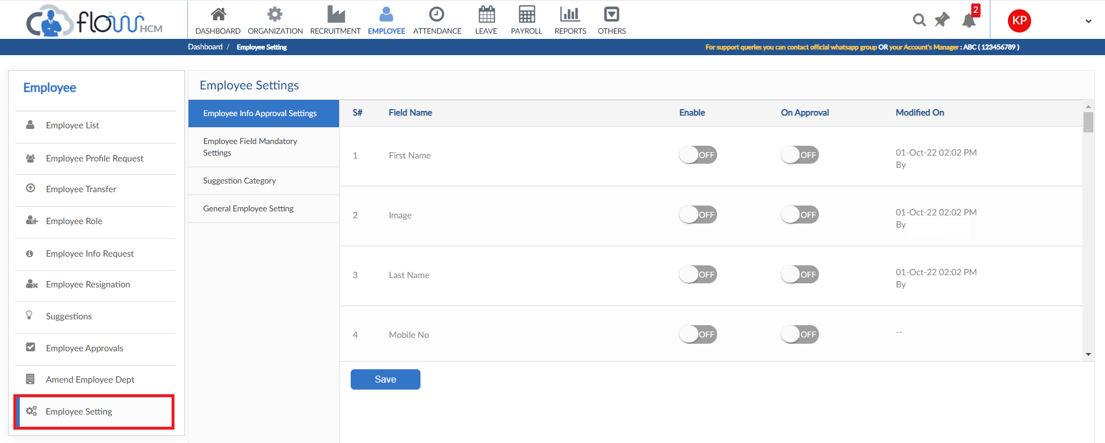

Employee Info Approval Setting
- To setup the enable field data in Employee Info request, click on Employee Info Approval Settings form in Employee Settings
- Name of fields are listed, select the toggle to enable the fields and set a approval
- Then click on Save button
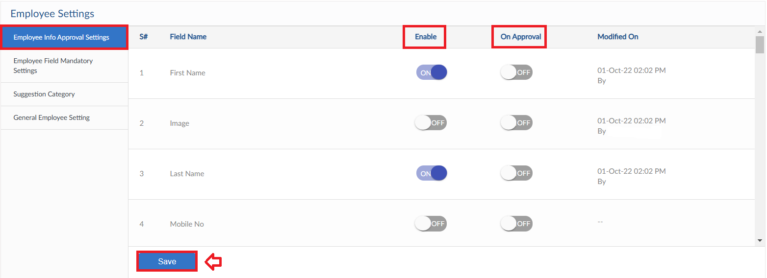

Employee Field Mandatory Settings
- To set mandatory fields in Employee List, click on Employee Filed Mandatory Settings form in Employee Settings
- Name of fields are listed within the Tabs, select the toggle to mark the fields mandatory
- User can also see the history by clicking on View History Button
- Then click on Save button
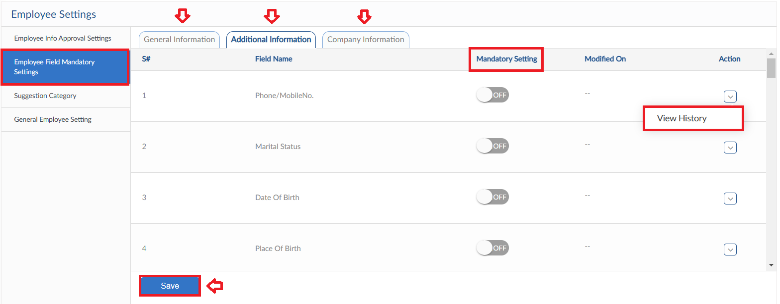

Suggestion Category
- To add a Category for Suggestions, click on Suggestion Category form in Employee Settings
- Click on Add Suggestion Category button, pop up will be visible
- Enter Category Title and select Suggest Anonymously YES/NO
- Select the intimation platform for suggestion (Notification/Email) and define the users as well from dropdowns
- Then click on Save button
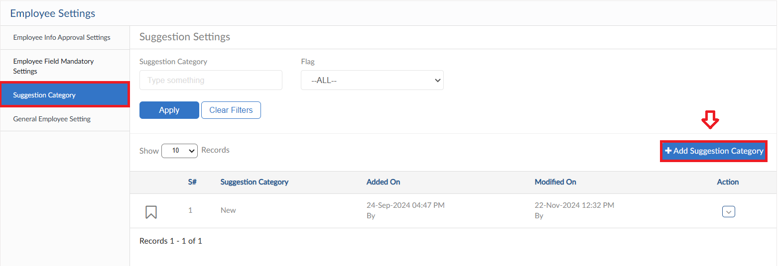
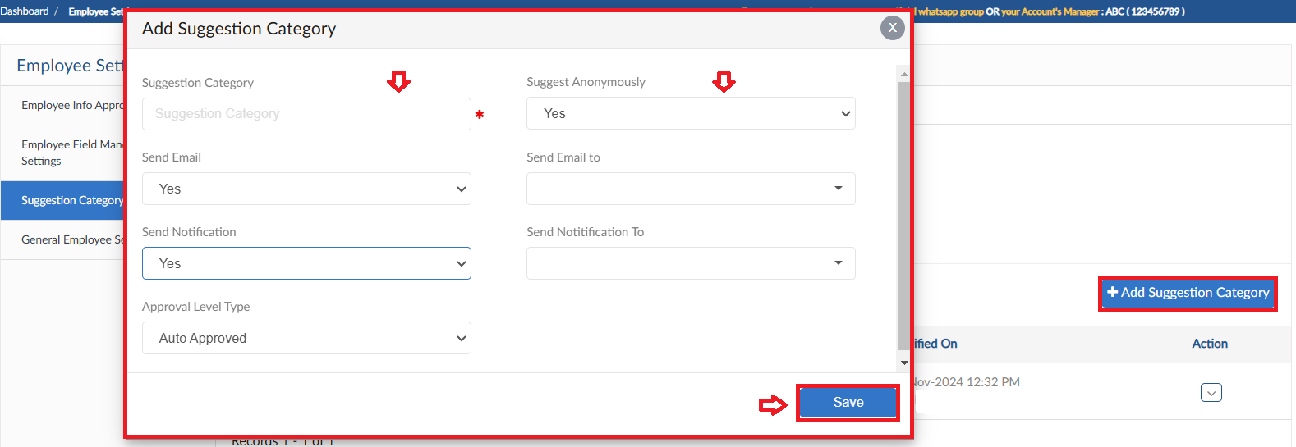

General Employee Setting
- General Employee Settings form consists of request approval hierarchy
- For every setting click Save button
